**Assignment -2**

|  |  |
| --- | --- |
| Assignment Date | 20 September 2022 |
| Student Name | S.vignesh |
| Student Roll Number | 723619104036 |
| Maximum Marks | 2 Marks |

**Question-1:**

1. Create a Flask App

1. Add the Home page, About Page

1. Add the Bootstrap

1. Add the Sign in page and App the Signup Page + database connectivity

**Solution:**

# ***index.js***

function deleteNote(noteId) {

fetch("/delete-note", { method: "POST", body: JSON.stringify({ noteId: noteId }),

}).then((_res) => { window.location.href = "/";

});

}

## ***base.html***

<!DOCTYPE html>

<html>

<head>

<meta charset="utf-8" />

<meta name="viewport" content="width=device-width, initial-scale=1" />

<link rel="stylesheet"

href="https://stackpath.bootstrapcdn.com/bootstrap/4.4.1/css/bootstrap.min.css"

integrity="sha384-Vkoo8x4CGsO3+Hhxv8T/Q5PaXtkKtu6ug5TOeNV6gBiFeWPGFN9MuhOf23Q9Ifjh" crossorigin="anonymous"

/>

<link rel="stylesheet" href="https://stackpath.bootstrapcdn.com/font-awesome/4.7.0/css/font-awesome.min.css" crossorigin="anonymous"

/>

<title>{% block title %}Home{% endblock %}</title>

</head>

<body>

<nav class="navbar navbar-expand-lg navbar-dark bg-dark">

<button class="navbar-toggler" type="button" data-toggle="collapse" data-target="#navbar"

>

<span class="navbar-toggler-icon"></span>

</button>

<div class="collapse navbar-collapse" id="navbar">

<div class="navbar-nav">

{% if user.is_authenticated %}

<a class="nav-item nav-link" id="home" href="/">Home</a>

<a class="nav-item nav-link" id="logout" href="/logout">Logout</a> {% else %}

<a class="nav-item nav-link" id="login" href="/login">Login</a>

<a class="nav-item nav-link" id="signUp" href="/sign-up">Sign Up</a> {% endif %}

</div>

</div>

</nav>

{% with messages = get_flashed_messages(with_categories=true) %} {% if messages %} {% for category, message in messages %} {% if category == 'error' %}

<div class="alert alert-danger alter-dismissable fade show" role="alert"> {{ message }}

<button type="button" class="close" data-dismiss="alert"> <span aria-hidden="true">&times;</span>

</button>

</div>

{% else %}

<div class="alert alert-success alter-dismissable fade show" role="alert"> {{ message }}

<button type="button" class="close" data-dismiss="alert"> <span aria-hidden="true">&times;</span>

</button>

</div>

{% endif %} {% endfor %} {% endif %} {% endwith %}

<div class="container">{% block content %} {% endblock %}</div>

<script src="https://code.jquery.com/jquery-3.2.1.slim.min.js" integrity="sha384-

KJ3o2DKtIkvYIK3UENzmM7KCkRr/rE9/Qpg6aAZGJwFDMVNA/GpGFF93hXpG5KkN" crossorigin="anonymous"

></script>

<script src="https://cdnjs.cloudflare.com/ajax/libs/popper.js/1.12.9/umd/popper.min.js" integrity="sha384-ApNbgh9B+Y1QKtv3Rn7W3mgPxhU9K/ScQsAP7hUibX39j7fakFPskvXusvfa0b4Q" crossorigin="anonymous"

></script>

<script src="https://maxcdn.bootstrapcdn.com/bootstrap/4.0.0/js/bootstrap.min.js" integrity="sha384-JZR6Spejh4U02d8jOt6vLEHfe/JQGiRRSQQxSfFWpi1MquVdAyjUar5+76PVCmYl" crossorigin="anonymous"

></script>

<script type="text/javascript" src="{{ url_for('static', filename='index.js') }}" ></script>

</body>

</html>

## ***home.hml***

{% extends "base.html" %} {% block title %}Home{% endblock %} {% block content %}

<h1 align="center">Notes</h1>

<ul class="list-group list-group-flush" id="notes">

{% for note in user.notes %}

<li class="list-group-item">

{{ note.data }}

<button type="button" class="close" onClick="deleteNote({{ note.id }})"> <span aria-hidden="true">&times;</span>

</button>

</li>

{% endfor %}

</ul>

<form method="POST">

<textarea name="note" id="note" class="form-control"></textarea> <br />

<div align="center">

<button type="submit" class="btn btn-primary">Add Note</button> </div>

</form>

{% endblock %}

## ***login.html***

{% extends "base.html" %} {% block title %}Login{% endblock %} {% block content %}

<form method="POST">

<h3 align="center">Login</h3>

<div class="form-group">

<label for="email">Email Address</label>

<input type="email" class="form-control" id="email" name="email"

placeholder="Enter email"

/>

</div>

<div class="form-group">

<label for="password">Password</label>

<input type="password" class="form-control" id="password" name="password" placeholder="Enter password"

/>

</div>

<br />

<button type="submit" class="btn btn-primary">Login</button>

</form>

{% endblock %}

## ***sign_up.html***

{% extends "base.html" %} {% block title %}Sign Up{% endblock %} {% block content %}

<form method="POST">

<h3 align="center">Sign Up</h3>

<div class="form-group">

<label for="email">Email Address</label>

<input type="email" class="form-control" id="email" name="email" placeholder="Enter email"

/>

</div>

<div class="form-group">

<label for="firstName">First Name</label>

<input type="text" class="form-control" id="firstName" name="firstName"

placeholder="Enter first name"

/>

</div>

<div class="form-group">

<label for="password1">Password</label>

<input type="password" class="form-control" id="password1" name="password1" placeholder="Enter password"

/>

</div>

<div class="form-group">

<label for="password2">Password (Confirm)</label>

<input type="password" class="form-control" id="password2" name="password2"

placeholder="Confirm password"

/>

</div>

<br />

<button type="submit" class="btn btn-primary">Submit</button>

</form>

{% endblock %}

## ***_init_.py***

from flask import Flask

from flask_sqlalchemy import SQLAlchemy from os import path

from flask_login import LoginManager

db = SQLAlchemy() DB_NAME = "database.db"

def create_app():

app = Flask( name )

app.config['SECRET_KEY'] = 'hjshjhdjah kjshkjdhjs'

app.config['SQLALCHEMY_DATABASE_URI'] = f'sqlite:///{DB_NAME}' db.init_app(app)

from .views import views

from .auth import auth

app.register_blueprint(views, url_prefix='/') app.register_blueprint(auth, url_prefix='/') from .models import User, Note create_database(app)

login_manager = LoginManager() login_manager.login_view = 'auth.login' login_manager.init_app(app)

@login_manager.user_loader def load_user(id): return User.query.get(int(id)) return app

def create_database(app):

if not path.exists('website/' + DB_NAME):

db.create_all(app=app)

print('Created Database!')

## ***auth.py***

from flask import Blueprint, render_template, request, flash, redirect, url_for from .models import User

from werkzeug.security import generate_password_hash, check_password_hash from . import db

from flask_login import login_user, login_required, logout_user, current_user

auth = Blueprint('auth', name )

@auth.route('/login', methods=['GET', 'POST']) def login():

if request.method == 'POST': email = request.form.get('email') password = request.form.get('password')

user = User.query.filter_by(email=email).first() if user: if check_password_hash(user.password, password): flash('Logged in successfully!', category='success')

login_user(user, remember=True) return redirect(url_for('views.home'))

else: flash('Incorrect password, try again.', category='error')

else:

flash('Email does not exist.', category='error')

return render_template("login.html", user=current_user)

@auth.route('/logout') @login_required def logout(): logout_user()

return redirect(url_for('auth.login'))

@auth.route('/sign-up', methods=['GET', 'POST']) def sign_up():

if request.method == 'POST':

email = request.form.get('email') first_name = request.form.get('firstName') password1 = request.form.get('password1') password2 = request.form.get('password2')

user = User.query.filter_by(email=email).first() if user:

flash('Email already exists.', category='error')

elif len(email) < 4:

flash('Email must be greater than 3 characters.', category='error')

elif len(first_name) < 2:

flash('First name must be greater than 1 character.', category='error')

elif password1 != password2:

flash('Passwords don\'t match.', category='error')

elif len(password1) < 7: flash('Password must be at least 7 characters.', category='error')

else:

new_user = User(email=email, first_name=first_name, password=generate_password_hash(

password1, method='sha256')) db.session.add(new_user) db.session.commit() login_user(new_user, remember=True) flash('Account created!', category='success') return redirect(url_for('views.home'))

return render_template("sign_up.html", user=current_user)

# ***models.py***

afrom . import db from flask_login import UserMixin

from sqlalchemy.sql import func

class Note(db.Model): id = db.Column(db.Integer, primary_key=True) data = db.Column(db.String(10000))

date = db.Column(db.DateTime(timezone=True), default=func.now()) user_id = db.Column(db.Integer, db.ForeignKey('user.id'))

class User(db.Model, UserMixin): id = db.Column(db.Integer, primary_key=True) email = db.Column(db.String(150), unique=True) password = db.Column(db.String(150)) first_name = db.Column(db.String(150))

notes = db.relationship('Note')

## ***views.py***

from flask import Blueprint, render_template, request, flash, jsonify from flask_login import login_required, current_user from .models import Note from . import db import json

views = Blueprint('views', name )

@views.route('/', methods=['GET', 'POST'])

@login_required def home():

if request.method == 'POST': note = request.form.get('note')

if len(note) < 1: flash('Note is too short!', category='error')

else:

new_note = Note(data=note, user_id=current_user.id) db.session.add(new_note) db.session.commit()

flash('Note added!', category='success')

return render_template("home.html", user=current_user) @views.route('/delete-note', methods=['POST']) def delete_note(): note = json.loads(request.data) noteId = note['noteId'] note = Note.query.get(noteId) if note:

if note.user_id == current_user.id:

db.session.delete(note)

db.session.commit()

return jsonify({})

**OUTPUT SCREENSHOTS**

**Step 1 :** enter our email address and password

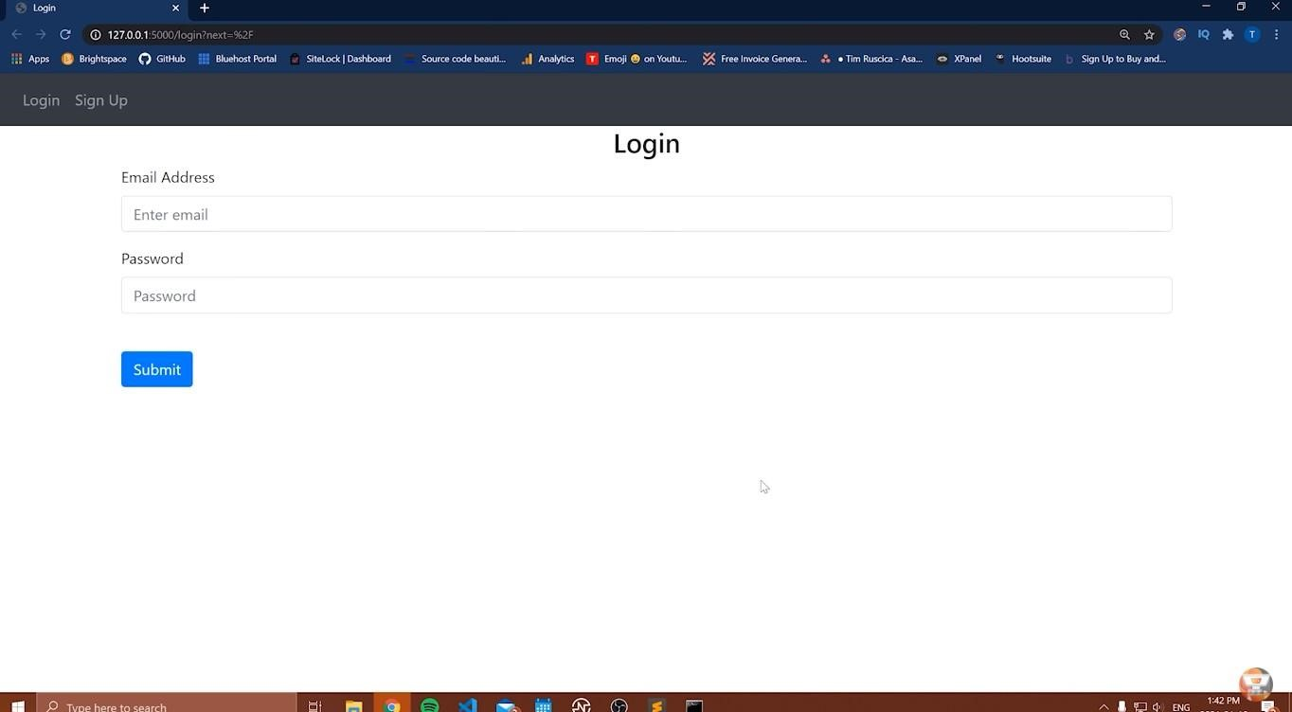

**STEP 2 :** After enter that click “Login”

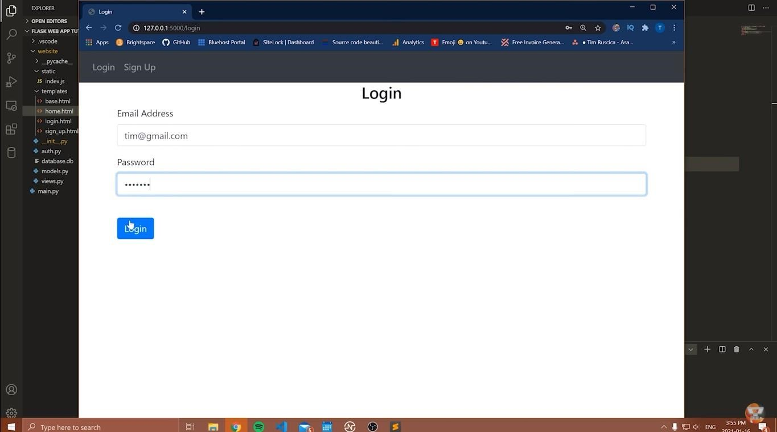

After that website redirect you to notes :

